UI/UX test of the site oxford-med.com.ua showed 5 bugs. Bugs have been added to the Jira backlog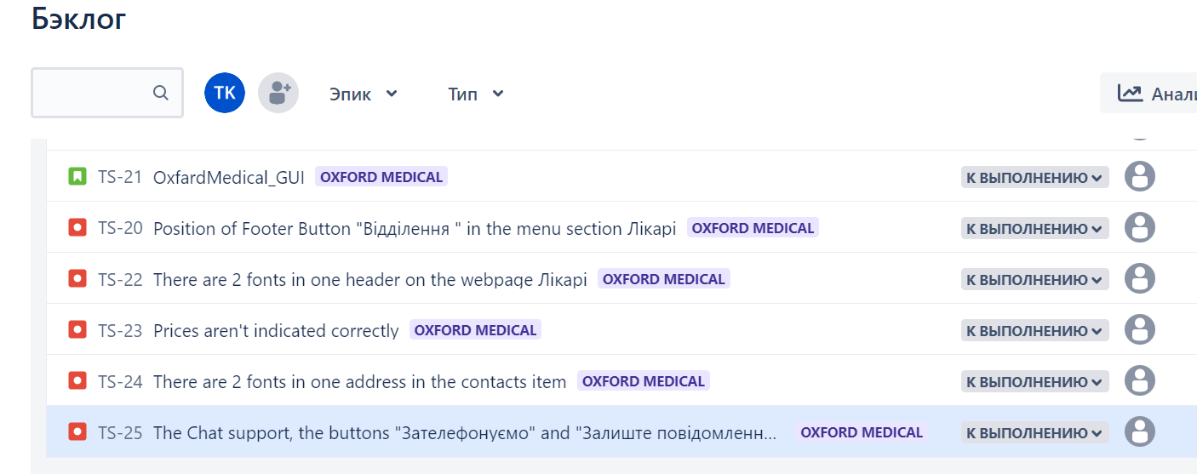

UI/UX test of the site https://www.kmlvm.com.ua showed 6 bugs. Bugs have been added to the Jira backlog



UI/UX test of the site https://zpolis.com.ua showed 5 bugs. Bugs have been added to the Jira backlog

